

**Department of Electrical and Computer Engineering**

| Course Number | CPS510 |
| --- | --- |
| Course Title | Database Systems I |
| Semester/Year | F2022 |
| Instructor | Dr. S. B. Tajali |
| Lab Section | 7 |

| Assignment No. | 4 |
| --- | --- |
| Assignment Title | Assignment 4: Simple Queries |

| Submission Date: | October 3, 2022 |
| --- | --- |
| Due Date: | October 3, 2022 |

| Student Name | Ethan Moo-Young | Ernestine Ho | Abel Abraham Thomas |
| --- | --- | --- | --- |
| Student ID | 501016708 | 501022253 | 501029194 |
| Signature |  |  |  |

Contents of [Book] Table

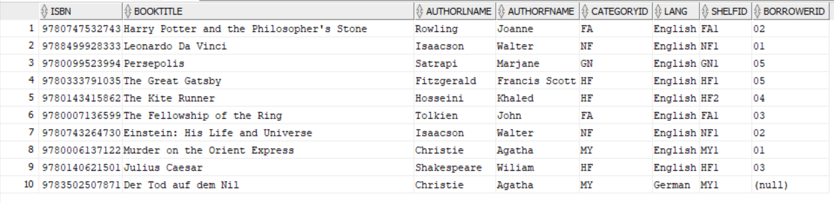

Contents of [Category] Table

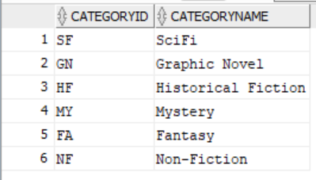

Contents of [Client] Table

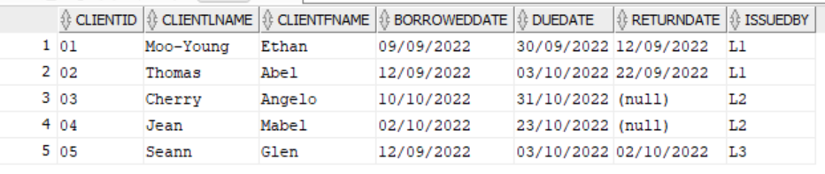

Contents of [Shelf] Table

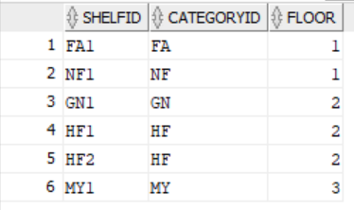

Contents of [Staff] Table

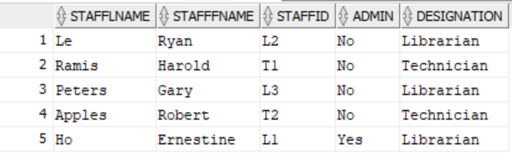

Simple Query searching for Fantasy Books grouped and ordered by Book Title:

| SELECT booktitle, COUNT(*) AS FA_BOOKS FROM book WHERE categoryid='FA' GROUP BY booktitle ORDER BY booktitle; |
| --- |

Query Result:

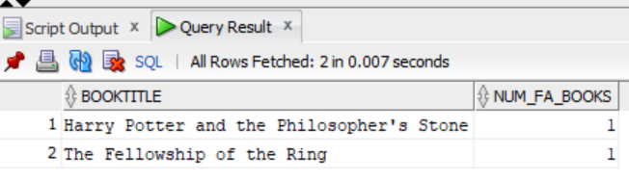

Simple Query searching for Clients with unreturned books, ordered by due date and grouped by full client name and due date:

| SELECT clientfname, clientlname, duedate AS not_returned FROM client WHERE returndate IS NULL GROUP BY clientfname, clientlname, duedate ORDER BY duedate; |
| --- |

Query Result:

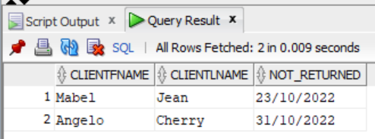

Simple Query searching for Clients issued by Librarian 1, ordered by Client ID and grouped by Client ID, Client Name and IssuedBy:

| SELECT issuedby, clientid, clientfname, clientlname AS issuedbyL1 FROM client WHERE issuedby='L1' GROUP BY clientid, clientfname, clientlname, issuedby ORDER BY clientid; |
| --- |

Query Result:

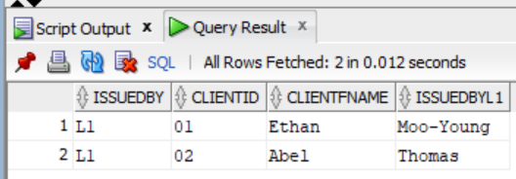

Simple Query searching Staff for designated Librarians ordering by first names in descending order, grouped by Staff name and designation:

| SELECT stafffname, stafflname, designation AS librarians FROM staff WHERE designation='Librarian' GROUP BY stafffname, stafflname, designation ORDER BY stafffname DESC; |
| --- |

Query Result:

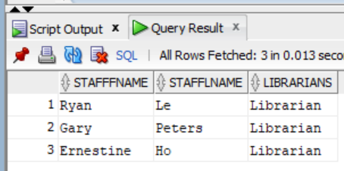

Simple Query searching Staff for designated technicians ordering by first names in ascending order, grouped by Staff name and designation:

| SELECT stafffname, stafflname, designation AS Technicians FROM staff WHERE designation='Technician' GROUP BY stafffname, stafflname, designation ORDER BY stafffname ASC; |
| --- |

Query Result:

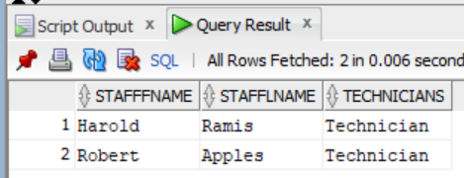

Simple Query searching from Shelf for Shelves listed under the HF category, grouped by Shelf ID, Category ID and Floor and ordered by Shelf ID

| SELECT shelfid, categoryid, floor FROM shelf WHERE categoryid='HF' GROUP BY shelfid, categoryid, floor ORDER BY shelfid; |
| --- |

Query Result:

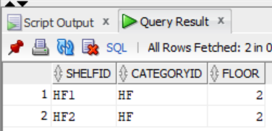

Simple Query searching Category, grouped by Category ID and Category Name, ordered by Category ID:

| SELECT categoryid, categoryname FROM category GROUP BY categoryid, categoryname ORDER BY categoryid; |
| --- |

Query Result:

